Notification regarding the Board of Management’s review of the Child Safeguarding Statement

To: Mercy College community - staff, students and parents

The Board of Management of Mercy College Coolock wishes to inform you that:

• The Board of Management’s annual review of the school’s Child Safeguarding Statement was completed at the Board meeting of 10th March 2022

• This review was conducted in accordance with the “Checklist for Review of the Child Safeguarding Statement” published on the Department’s ‘website www.education.ie

Signed 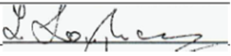 Date 10th March 2022

Chairperson, Board of Management

Signed 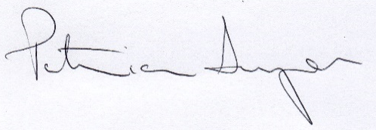 Date 10th March 2022

Principal/Secretary to the Board of Management

